1. **Agenda:**
   1. Why do we need **OpenAPI Specification**?
   2. What problems does OpenAPI Specification solve when dealing with API Development?
2. Like we discussed earlier that APIs help different organizations/apps to interact with each other.  
   But whenever these different applications interact with each other without OpenAPI Specification, they have to face certain problems/challenges.  
   Definitely, before the invention of OpenAPI Specification, our entire industry faced those challenges.
3. **Let’s talk about the problems without OpenAPI Specification**:  
   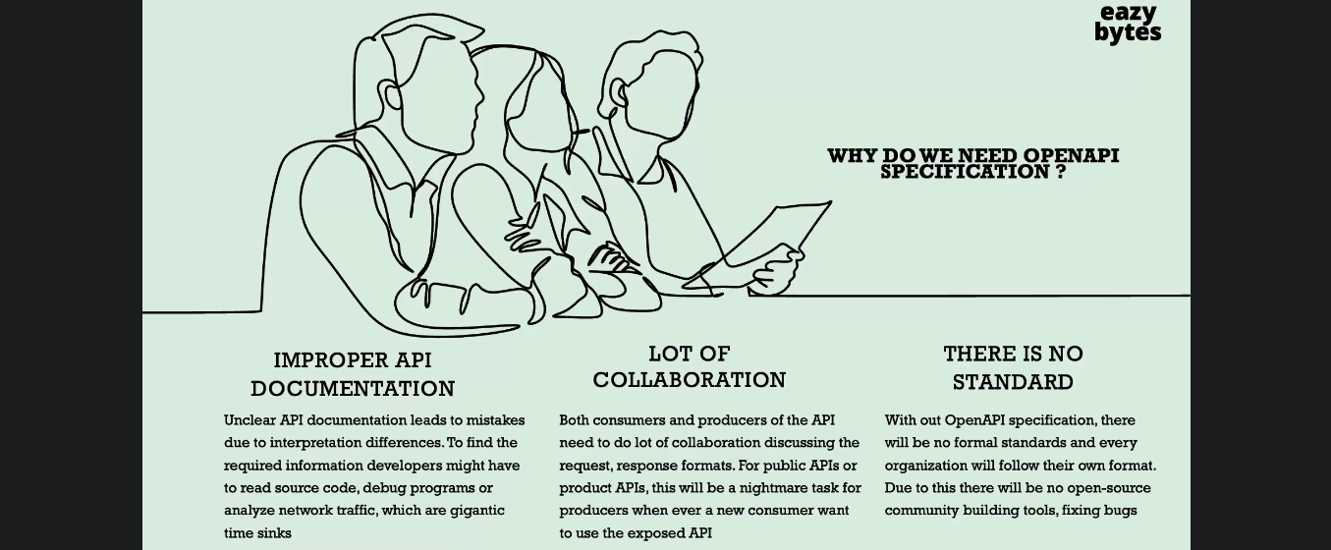
   1. **No proper API Documentation**:
      1. If we’re a consumer and want to consume some APIs by some organization, we heavily depend on those APIs’ documentation prepared by that organization to understand what the request/response structure parameters, URLs are.
      2. But the documentation created by a human (Developer or Business Analyst) may lead to unclear/improper API Documentation.  
         Like someone may explain in the documentation that for so-and-so field, I am going to accept a String Value.  
         But the consumer can assume that there is no length restriction.  
         So, there are a lot of scopes for mistakes as these API documentation was written by a Developer/BA which leads to a lot of mistakes.  
         Whereas a Developer consuming the APIs (with not proper documentation) has to read the source code, debug the code, analyze the Network Traffic to understand what is the real issue.  
         Eventually, they will identify that this is a Documentation Issue.
      3. So, these are the pain points due to the improper API Documentation.
   2. **Lot of Collaboration:**
      1. The second problem faced by the industry and the API Developers before OpenAPI Specification is that there is a lot of collaboration with consumers and producer of an APIs as Developers (Producers) have to arrange some meetings or KT Sessions with the consumers to explain them the response/response structure, the parameters etc which is a hell when a new consumer is onboarded.
   3. **There is no standard:**
      1. Like Every organization follows their own format standards to define their APIs.
      2. As there is no standard, there is no open-source community building tools around this API specification.
4. See the following snapshot and don’t worry about anything.   
   Graphical user interface, text, application

   Description automatically generated
   1. The left-hand side is the yaml document by following the OpenAPI Standards.  
      We can write in JSON also.   
      We will see how to write it.
   2. So, whenever we define the details of my APIs with the help of OpenAPI standards, so there are good  
      amount of tools like **Swagger Editor or Swagger UI**, which will help us to visualize the documentation in  
      an easily understandable format.
   3. So, we can see here on the right hand-side, we have an UI web page, which is an exact representation of whatever we have written on the left hand side using the OpenAPI Standards.
5. So, in this course, we are going to take a scenario where we have E-Commerce App named **EasyShop** which will expose its own APIs to outside vendors who can consume the APIs to show their product list on their own website and they will take an order and will send the order to EasyShop by using their APIs and EasyShop will deliver the order to the customer.
6. Mentor explain about the above snapshot regarding what we’re going to discuss but that is totally irrelevant as it is all about this and that APIs which we don’t need to watch again.